**Setup PowerSchool Unified Classroom for Existing Parent**

These instructions are for parents that currently have a PowerSchool Parent account and need to create a login to access PowerSchool Unified Classroom. If you never had a PowerSchool Parent account before please contact your school.

1. Go to the district website. [Create Unified Classroom Login](https://accounts.powerschool.com/as/authorization.oauth2?response_type=code&client_id=powerschoolsis&scope=address+phone+openid+profile+email&redirect_uri=https%3A%2F%2Fiec.powerschool.com%2Foidc%2Fopenid_connect_login&nonce=39103cb1229cb&state=258a5c735e5d&_local_login_portal=PARENT&_local_login_name=PowerSchool+SIS&_local_login_url=https%3A%2F%2Fiec.powerschool.com%2Fguardian%2Fhome.html%3F_userTypeHint%3Dguardian%26_local_login%3Dtrue)
2. Click on the **PowerSchool quick link**

[Create Unified Classroom Login](https://accounts.powerschool.com/as/authorization.oauth2?response_type=code&client_id=powerschoolsis&scope=address+phone+openid+profile+email&redirect_uri=https%3A%2F%2Fiec.powerschool.com%2Foidc%2Fopenid_connect_login&nonce=39103cb1229cb&state=258a5c735e5d&_local_login_portal=PARENT&_local_login_name=PowerSchool+SIS&_local_login_url=https%3A%2F%2Fiec.powerschool.com%2Fguardian%2Fhome.html%3F_userTypeHint%3Dguardian%26_local_login%3Dtrue)

1. Click on **Step 1: Set Up Your New PowerSchool ID**

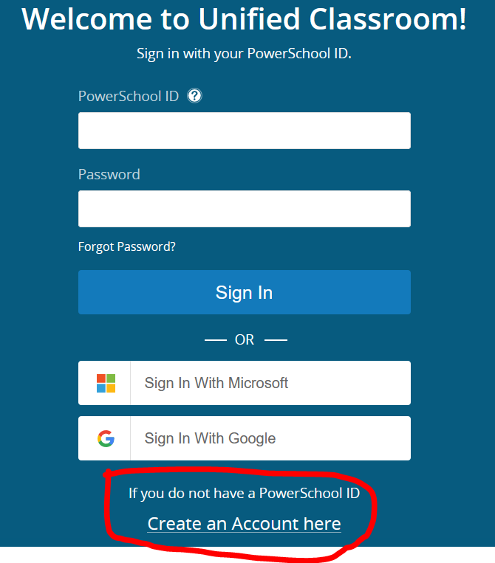

1. Click on **Create PowerSchool ID**

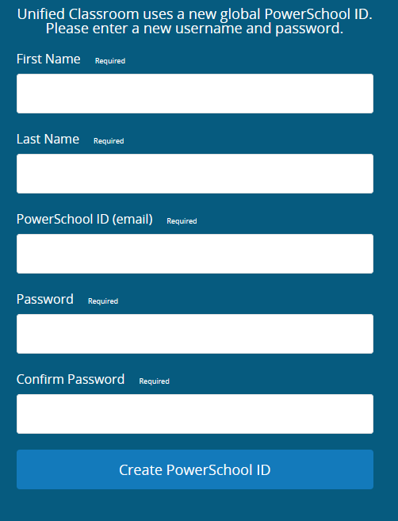

1. Fill out the form. The PowerSchool ID (Email) can be the same email you are currently using. The password has a minimum of 8 characters long.

1. Click **Create PowerSchool ID**

1. A confirmation message will appear. Click on Continue to Unified Classroom Sign In.
2. 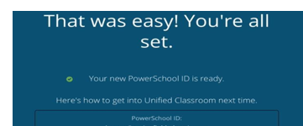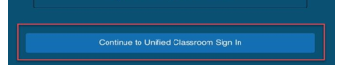

1. Sign in with the Unified Classroom account that was just created.

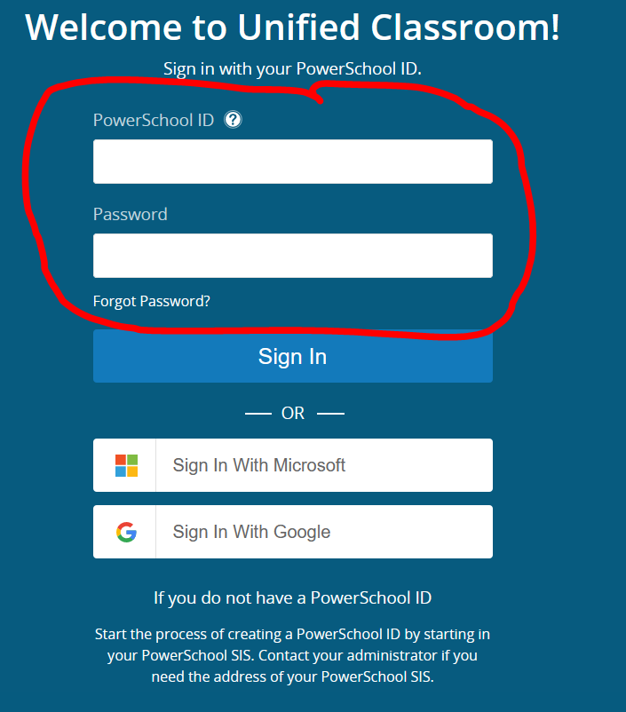

1. Click on **“I Have a Username and Password in My District’s PowerSchool Parent Portal”**

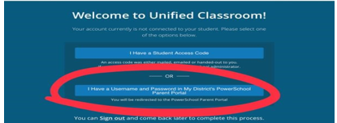

1. Sign in using the

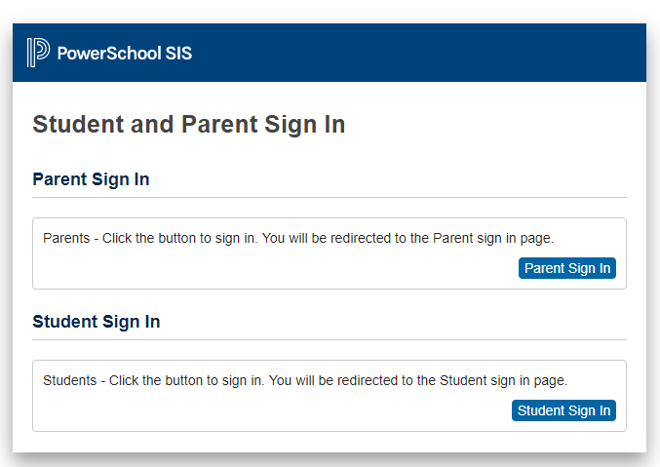

**NOTE**: If you could not recall your old PowerSchool Parent Portal password and our staff had to reset your password you will have one more step below.

* + **Current Password:** Re-enter the new temporary password that our staff has assigned for you.
  + **New Password:** Enter a new password. This password can be the same as your PowerSchool Unified Classroom password you recently created. This password will only be used to link both accounts.
  + **Re-Enter New Password:** Re-enter the same password a second time and click Enter.

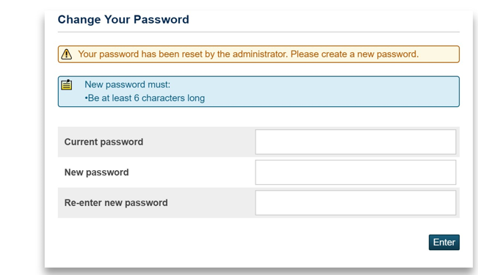

1. Your PowerSchool Unified Classroom and PowerSchool Parent Portal account is now linked and you will be taken to the PowerSchool Unified Classroom dashboard.

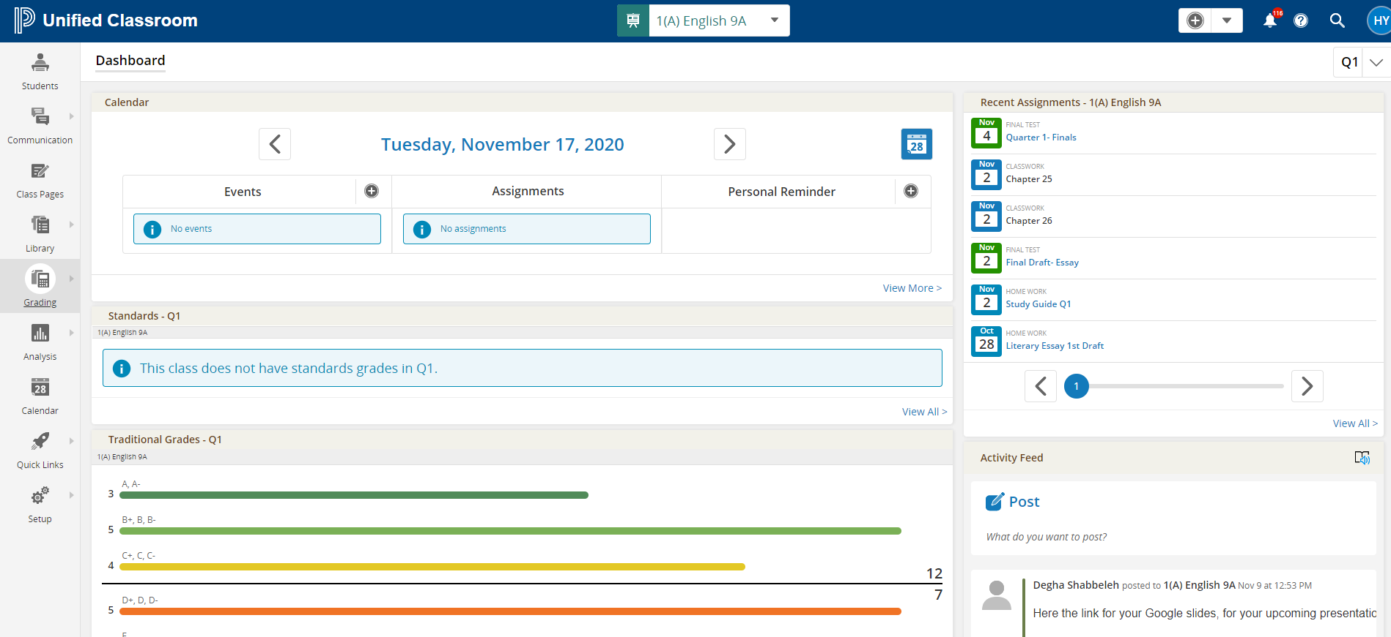

1. 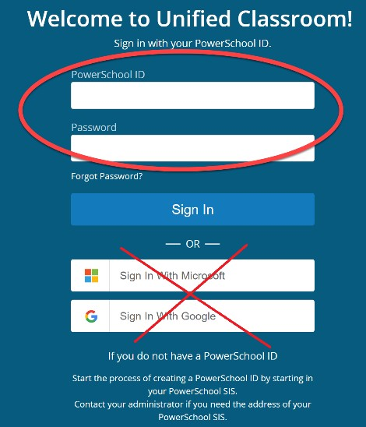You may login to PowerSchool Unified Classroom anytime by going to the link below and signing in with your **PowerSchool ID and Password**. If you can’t recall your PowerSchool Unified Classroom password you can click on **Forgot Password** and you will receive an email to reset your password.

<https://classroom.powerschool.com/>